

**CSC301: VISUAL PROGRAMMING**

TUITION CENTRE MANAGEMENT SYSTEM

**Final Report**

|  |  |
| --- | --- |
| Program Code | : CS110 |
| Group | : M3CS1105A |
| Prepared for | : Mr. Zainal Fikri bin Zamzuri, |
|  | Faculty of Computer & Mathematical Sciences |

Prepared by:

|  |  |
| --- | --- |
| **Name** | **Matrix Number** |
| Izz Hadri Bin Hamidi | 2016699248 |
| Muhammad Iqbal Bin Zamri | 2015845736 |
| Muhammad Adib Bin Abdul Rahim | 2016485692 |
| Muhammad Amir Firdaus Bin Mohd Soyapi | 2016493568 |

**TABLE OF CONTENT**

|  |  |  |
| --- | --- | --- |
| **No.** | **Title** | **Page** |
| 1 | Business Rules | 3-4 |
| 2 | Entity Relationship Diagram (ERD) | 5 |
| 3 | Data Dictionary | 6-10 |
| 4 | User Manual | 11- |

**BUSINESS RULES**



*Relationship: (Many to Many)*

* One student can learn many subject, one subject can be learnt by many students.



*Relationship: (Many to Many)*

* One teacher can teach many subject, one subject can be taught by many teachers.

**

*Relationship: (Many to Many)*

* One admin can deal with many teachers and students. one teachers and student can be dealt by many admin.

**

*Relationship: (Many to Many)*

* One teacher can teach many subject, one subject can be taught by many teachers.

**

*Relationship: (Many to Many)*

* One student can learn many subject, one subject can be learnt by many students.

**ENTITY RELATIONSHIP DIAGRAM (ERD)**



**DATA DICTIONARY**

Admin Table

|  |  |  |  |  |  |  |
| --- | --- | --- | --- | --- | --- | --- |
| Attributes | Field Name | Field  Size | Data  Type | Primary  Key | Foreign  Key | Explanation |
| 1. | admin_id | Long  integer | Number | PK |  | Id for admin |
| 2. | admin_pass | 255 | Short text |  |  | Password for admin |
| 3. | admin_name | 255 | Short text |  |  | Admin name |
| 4. | admin_phoneno | 255 | Short text |  |  | Admin phone number |
| 5. | admin_address |  | Long text |  |  | Admin address |
| 6. | admin_email | 255 | Short text |  |  | Admin email |

Deal Table

|  |  |  |  |  |  |  |
| --- | --- | --- | --- | --- | --- | --- |
| Attributes | Field Name | Field  Size | Data  Type | Primary  Key | Foreign  Key | Explanation |
| 1. | admin_id | Long  integer | Number | PK | FK | Id for admin |
| 2. | tcr_id | Long  integer | Number | PK | FK | Id for teacher |
| 3. | std_id | Long  integer | Number | PK | FK | Id for student |

Learn Table

|  |  |  |  |  |  |  |
| --- | --- | --- | --- | --- | --- | --- |
| Attributes | Field Name | Field  Size | Data  Type | Primary  Key | Foreign  Key | Explanation |
| 1. | std_id | Long  integer | Number | PK | FK | Id for student |
| 2. | sub_code | 255 | Short text | PK | FK | Subject code |
| 3. | timetable_day | 255 | Short text |  |  | Day of the timetable |
| 4. | timetable_session | Long  integer | Number |  |  | Session of the timetable |

LearnTemp Table

|  |  |  |  |  |  |  |
| --- | --- | --- | --- | --- | --- | --- |
| Attributes | Field Name | Field  Size | Data  Type | Primary  Key | Foreign  Key | Explanation |
| 1. | std_id | Long  integer | Number | PK | FK | Id for student |
| 2. | sub_code | 255 | Short text | PK | FK | Subject code |

Student Table

|  |  |  |  |  |  |  |
| --- | --- | --- | --- | --- | --- | --- |
| Attributes | Field Name | Field  Size | Data  Type | Primary  Key | Foreign  Key | Explanation |
| 1. | std_id | Long  integer | Number | PK |  | Id for student |
| 2. | std_ic |  | Long text |  |  | Student ic number |
| 3. | std_name |  | Long text |  |  | Student name |
| 4. | std_sex | 255 | Short text |  |  | Student sex |
| 5. | std_email |  | Long text |  |  | Student email |
| 6. | std_category | 255 | Short text |  |  | Student category |
| 7. | std_address |  | Long text |  |  | Student address |
| 8. | std_parentno | Long  integer | Number |  |  | Parent phone number of the student |
| 9. | std_phoneno | Long  integer | Number |  |  | Student phone number |
| 10. | std_pass | 255 | Short text |  |  | Student password |
| 11. | std_pic | 255 | Short text |  |  | Student picture |

Subject Table

|  |  |  |  |  |  |  |
| --- | --- | --- | --- | --- | --- | --- |
| Attributes | Field Name | Field  Size | Data  Type | Primary  Key | Foreign  Key | Explanation |
| 1. | sub_code | 255 | Short text | PK |  | Subject code |
| 2. | sub_module |  | Long text |  |  | Subject module |
| 3. | sub_name |  | Long text |  |  | Subject name |
| 4. | sub_price | Long  integer | Number |  |  | Subject price |

Teach Table

|  |  |  |  |  |  |  |
| --- | --- | --- | --- | --- | --- | --- |
| Attributes | Field Name | Field  Size | Data  Type | Primary  Key | Foreign  Key | Explanation |
| 1. | tcr_id | Long  integer | Number | PK | FK | Id for teacher |
| 2. | sub_code | 255 | Short text | PK | FK | Subject code |
| 3. | timetable_day | 255 | Short text |  |  | Day of the timetable |
| 4. | timetable_session | Long  integer | Number |  |  | Session of the timetable |

Teacher Table

|  |  |  |  |  |  |  |  |
| --- | --- | --- | --- | --- | --- | --- | --- |
| Attributes | Field Name | Field  Size | Data  Type | Primary  Key | | Foreign  Key | Explanation |
| 1. | tcr_id | Long  integer | Number | PK |  | | Id for teacher |
| 2. | tcr_ic |  | Long text |  |  | | Teacher ic number |
| 3. | tcr_sex | 255 | Short text |  |  | | Teacher sex |
| 4. | tcr_name |  | Long text |  |  | | Teacher name |
| 5. | tcr_status | 255 | Short text |  |  | | Teacher status |
| 6. | tcr_email | 255 | Short text |  |  | | Teacher email |
| 7. | tcr_address |  | Long text |  |  | | Teacher address |
| 8. | tcr_phoneno | Long  integer | Number |  |  | | Teacher phone number |
| 9. | tcr_pass | 255 | Short text |  |  | | Teacher password |
| 10. | tcr_pic | 255 | Short text |  |  | | Teacher picture |

TeachTemp Table

|  |  |  |  |  |  |  |
| --- | --- | --- | --- | --- | --- | --- |
| Attributes | Field Name | Field  Size | Data  Type | Primary  Key | Foreign  Key | Explanation |
| 1. | tcr_id | Long  integer | Number | PK | FK | Id for teacher |
| 2. | sub_code | 255 | Short text | PK | FK | Subject code |

**USER MANUAL**

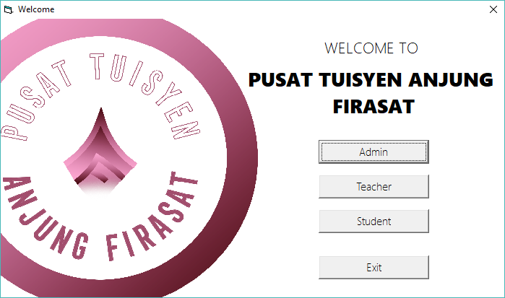

Figure 1: Main page

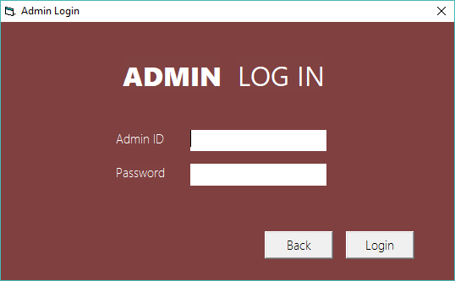

Figure 2: Admin login

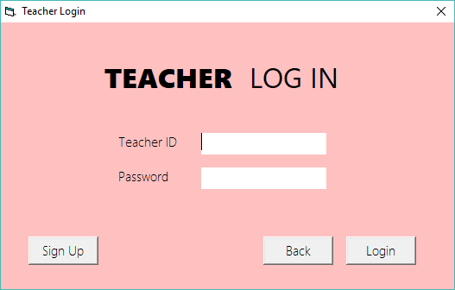

Figure 3: Teacher login

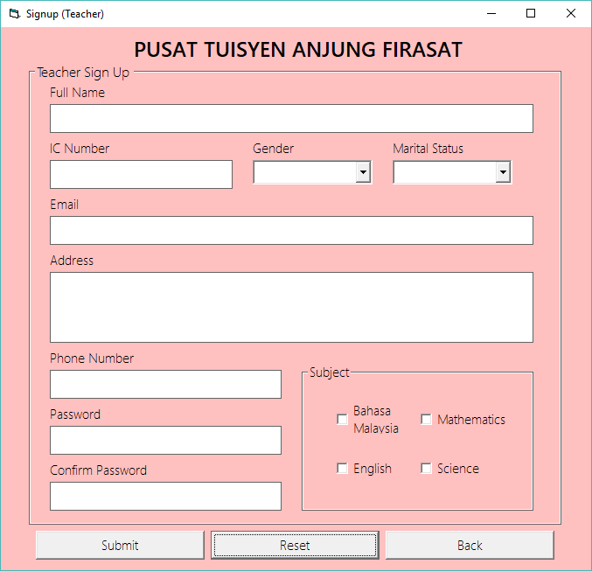

Figure 4:Signup teacher

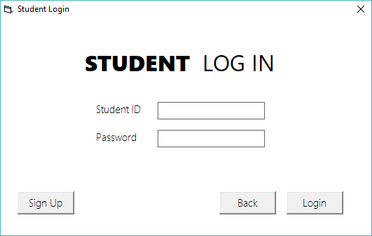

Figure 5: Student login

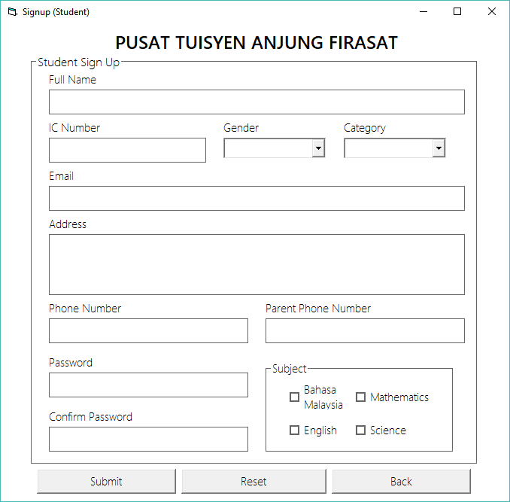

Figure 6: Signup student

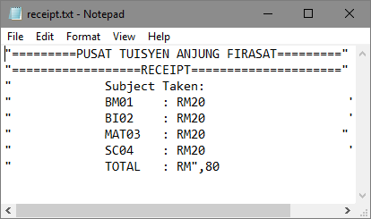

Figure 7: Receipt of Subject Price After the Registration

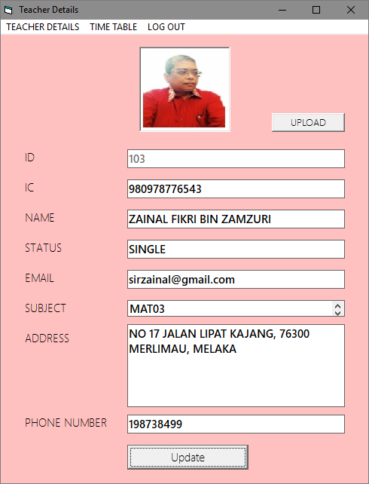

Figure 8: Teacher Details

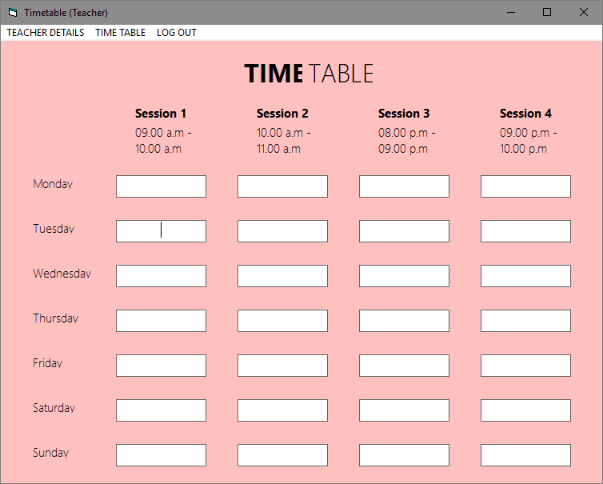

Figure 9:Teacher Timetable

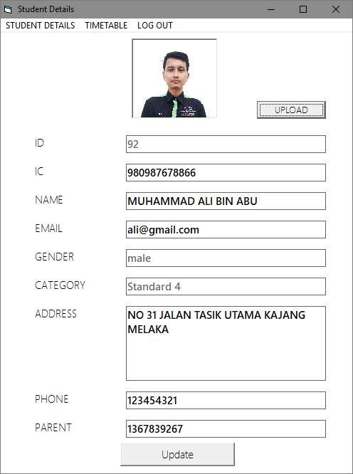

Figure 10: Student Details

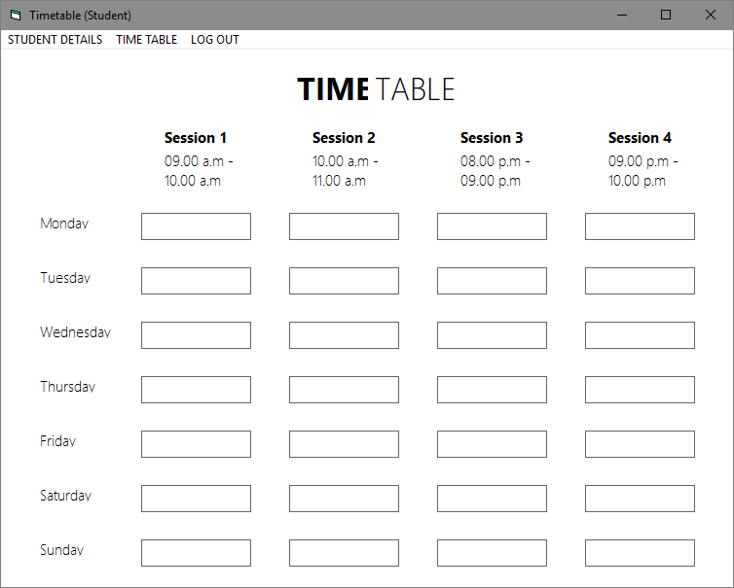

Figure 11: Timetable student

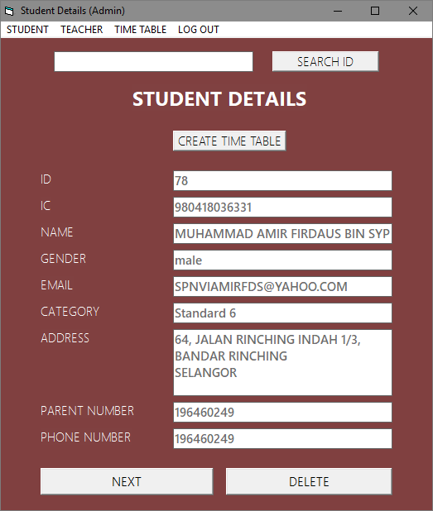

Figure 12: Student details for admin

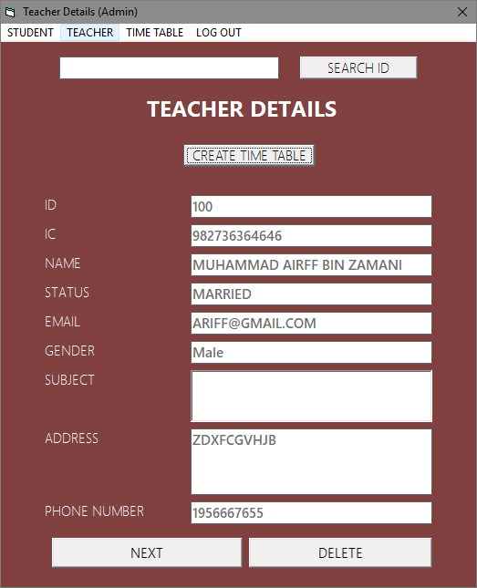

Figure 13:Teacher Details Admin

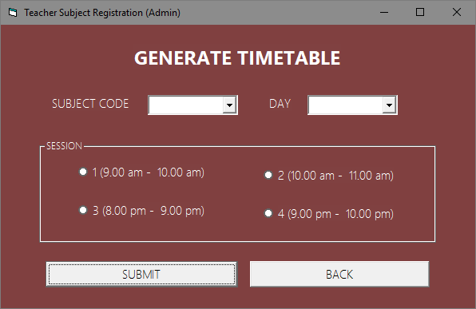

Figure 14: Timetable Registration